Lab4 Diabetic Retinopathy Detection

1. Introduction

Use the Resnet 50 and 18 model to detect diabetic retinopathy , and show the confusion matrix .

model.py : return Resnet 50 , 18 , with , w/o pretrained model .

train.py : training code .

test.py : testing code .

dataLoader.py : my own dataloader .

1. Experiment setups

A : Details of model:

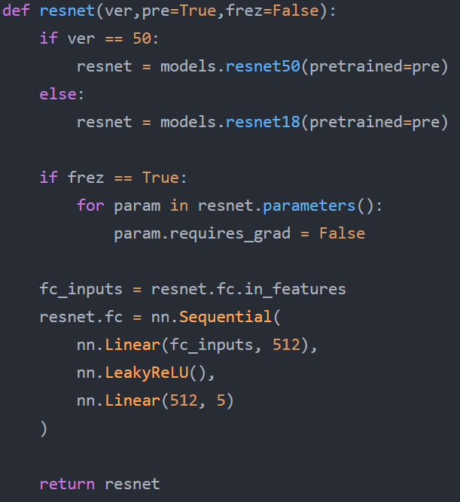

In model.py , I change the last layer to two fully connection layer and one activation function layer , and you can set the parameters to get the different model .

B : Details of DataLoader :

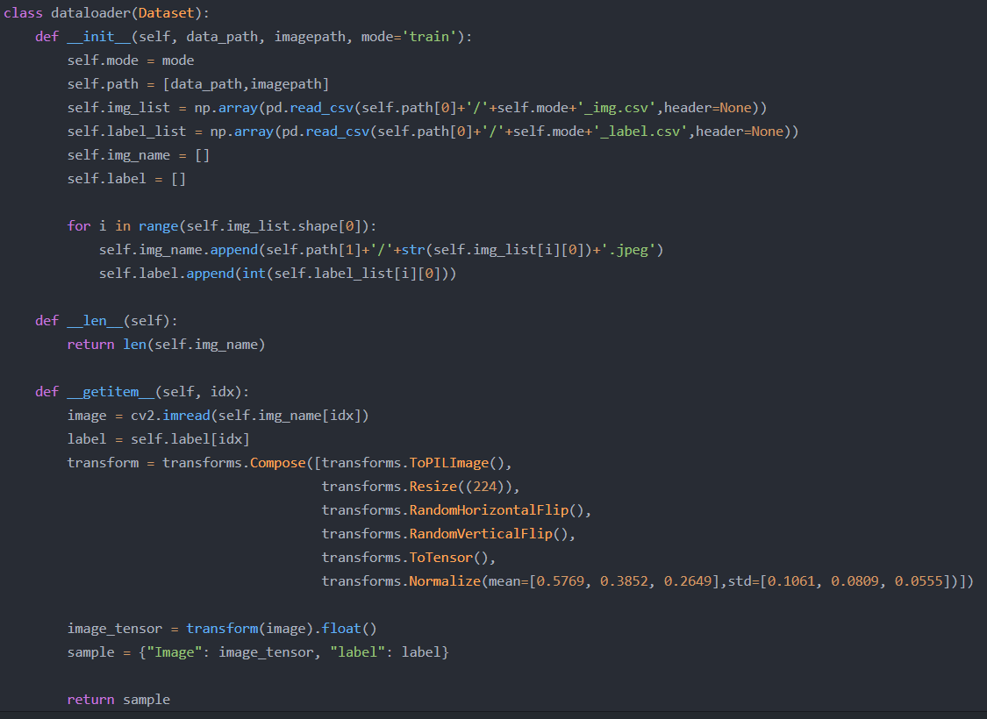

In __getitem__ , I use the transforms to prevent overfitting . And it will return the dictionary which includes image and label .

C : Evaluation of confusion matrix

In evaluation of confusion matrix , It can clear present the detection rate between each two classes . So we expect the higher values located on the upper left and lower right diagonal .

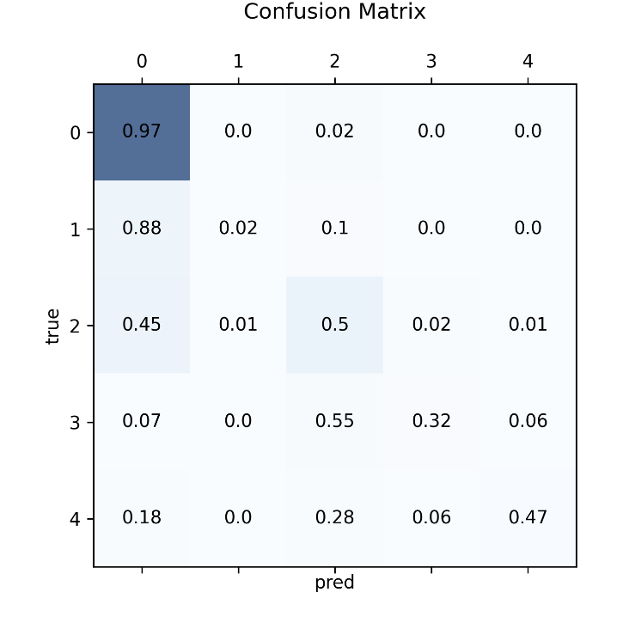

1. Experiment results

A : The highest testing accuracy : 80 %

I use the Resnet 50 with pretrained weight , batch size=32 , lr=0.001, epoch=11 , weight decay=0.001 , and testing accuracy is 80% .



Although the accuracy is 80% , but all classes expect 0 are far below this value , and take a look in training data , the numbers of class 0 images is 20000 , accounting for 71% of the total , so I think it have a overfitting .

Loss curve :

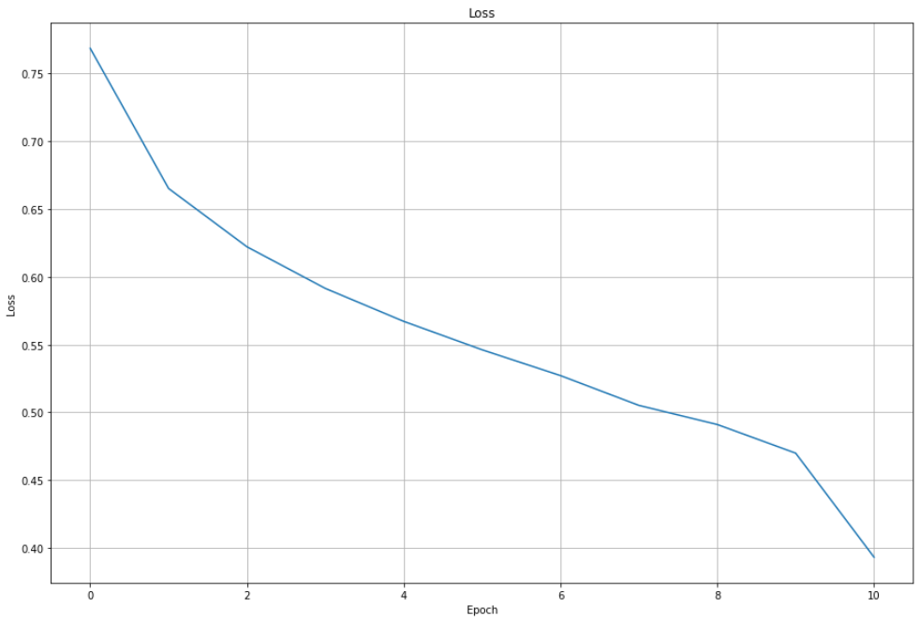

Accuracy curve :

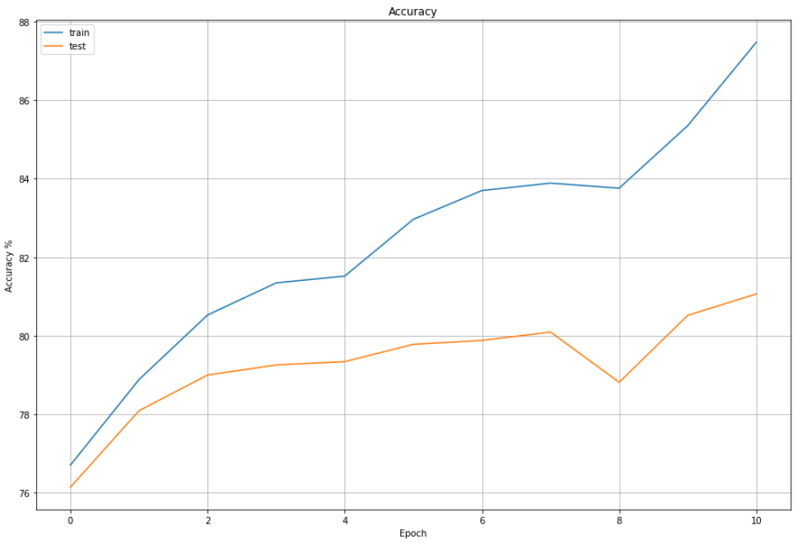

B : Comparsion figures:

The final accuracy is no far between using pretrained weight or not , I think it is because I used pretrained weight without freezing the gradient backward .

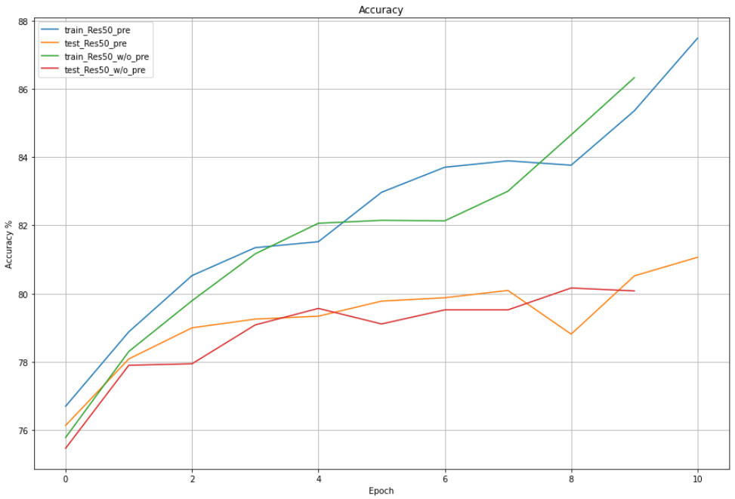

1. Discussion

To overcome overfitting , I add the weight loss to the loss function :

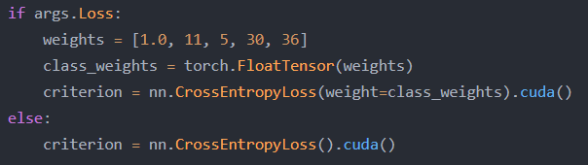

As a result , although the total accuracy is lower , but the accuracy of each class is better .

